1.DÖNEM YARIYIL TESTİ

1) Jane : The weather is very nice.Do you want to go for a walk ,buddy?
Kate : I’d love to ,but - - - - - - - - - - - - .
A) I don’t feel well today C) That’s a good idea
B) Sounds fun D) I like jogging

2) Jack : Are you busy on Saturday afternoon ?
Sally : - - - - - - - - - - - -
Jack : I ‘d like to go shopping .Do you want to come along with me ?
Sally: Sure.I need shopping ,too.

- Sure.I’d love to .
- Sorry,buddy.I am busy then
C) I am afraid ,I can’t .
D) Not,really .Why ?
3-Martin : How do you - - - - - - - - - - your friends ?
Tom : I usually text messages.

- make phone conservation
- social networks
- keep in touch with
- disguise

4-Adam :Hello.Can I speak to Mr Mutlu, please?
Secretary: - - - - - - - - - - - -
Adam :This is Adam Wolf .

- Hold on ,please.I ‘ll put through.
- Can I take your telephone number?
- I am sorry,he is engaged now.
- May I ask who is calling ?

5-Amy : This apple pie is very tasty - - - - - - - - - ?
Katie: Sure.Have you got a pen and paper?
Amy : Yes.I am writing .

- Can you give me the recipe?
- What is in it?
- What do you need for it?
- How often do you cook it?

6-Donna:- - - - - - - - - - - - - - ?
Jane :Three times a week.

- What time do you go swimming ?
- How often do you go swimming ?
- Where do you go swimming?
- Can you swim well ?

7) Katie: I am sorry she isn’t here.She is at the
hospital .
Marie:Oh, - - - - - - - - - - - .
- I am glad to hear that C)I am sorry to hear that
- I am happy to hear that D)Thank for calling

8-Helen : Do you listen to jazz music?
Andy : No, - - - - - - - - - .I think it is unbearable.

- I am good at it C)I am fond of it
- I can’t stand it D) I am crazy about it

9.Aşağıdaki metinde hangi iletişim yolundan bahsedilmemiştir?
People always communicate with their families .They usually prefer sending instant messages by means of their mobile phones.Also ,they often make calls and send e-mails.

A) C)
B) D)
10-Aşağıdaki eşleştirmelerden hangisi yanlıştır ?
- Accepting : Of course.What time?
- Inviting: Would you like to come with me?
- Refusing: Yeah,I’ll be there for sure.
- Apologising: I ‘m sorry ,but I can’t .
11-Başlığa uygun olmayan ifade hangisidir?
Different ways of communication
●send a text messag
●leave a message
● - - - - - - - - - - - -
A) Use hands and faces C) Make a phone call
B) Hold the line D) Talk and write
12-What is the title of the list ?
● - - - - - - - - - - - - -  ●2 glasses of milk  ●some sugar  ●2 tablespoons of oil | A) Ingredients  B)Recipe  C)Process  D)Experts

Tabloya göre 13.ve 14.soruları cevaplayınız.

Sarah | Hello,friends.I am going to have a New Year Party.We ‘ll have a great time.Fancy joining us ?Please,let me know as soon as possible.
David | I’d love to ,but I am going to welcome to 2018 with my family at my place.
Julie | Sounds fun .I ‘ll be definitely there
Carol | Sure.I love parties .
13-Which one is FALSE ?
A) Sarah is organising a party.
B) David will be busy on 31st December.
C) Julie isn’t going to attend to the party .
D) Carol accepts the invitation.

14-Why does David refuse the invitation ?
A) Because he is going to be at home with his family.
B) Because he doesn’t like parties
C) Because he will be out of city then
D) Because he is organising a New Year party,too.

15-Görsele göre aşağıdakilerden hangisi doğrudur?
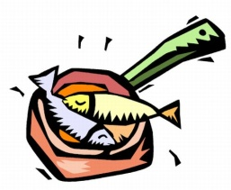

A) He prefers fried fish to grilled fish.
B) He prefers grilled fish to fried fish .
C) He doesn’t prefer grilled fish .
D) He can’t stand grilled fish .

16- “I’m glad to hear that.” cümlesinde koyu renkle
yazılmış olan kelimenin yerine hangisi getirilebilir?
A) worried B) sorry C) upset D) happy

17-Verilen cümlelerle anlamlı bir sıralama yapıldığında aşağıdakilerden hangisi doğrudur?

I- Finally ,serve it immediately
II- Firstly,dice the potatoes and add salt, pepper and olive oil
III- After that ,take it out and put on the plate .
IV- Next,put into the oven and bake it for 20 minutes

A) II-I-IV-III C) II-IV-III-I
B) I-II-III-IV D) II-III-IV-I

18-Sherlock: Hi, Is Dr. Watson there?
Secretary: Hold on. - - - - - - - - - - -
Dr. Watson: Hi Sherlock. It’s me.
A) Would you like to leave a message?
B) I’m afraid he has gone out.
C) Who is calling?
D) I’ll put you through.

19) Yoda: Hi, this is Yoda. Can I talk to Luke please.
Dart Wader: I’m sorry - - - - - - - - - - Would you like to leave a message?
Yoda: No, thanks. I’ll call back later.

A) He is present now.
B) He isn’t available now.
C) He’s here at the moment.
D) He isn’t busy now.
20) Verilen cümlelerde boş bırakılan yerlere aşağıdaki fiillerden hangisi getirilemez.
I - - - - - it in half to melt the cheese
II - - - - - the oil in a frying pan and pour the mixture into the frying pan
III - - - - - the mixture until it’s golden brown

A) Add B) Fold C) Heat D)Cook
21) I don’t prefer eating fried food because I know it is too - - - - - - - - - - .
A) creamy B) sweet C) tasty D) fattening

22. When you are at the theater, - - - - your phone.
A) ring C) switch off
B) receive D) exchange

23. - - - -?Bees dance and tell the others where the food is.

A) How do bees exchange information
B) How can humans communicate
C) Do you know how bees sing songs
D) How do elephants make sound

24) Which one is the mean of “writing system using picture symbols”

A) social media C) hand writing
B) hieroglyphics D) posting

25) What kind of party is it?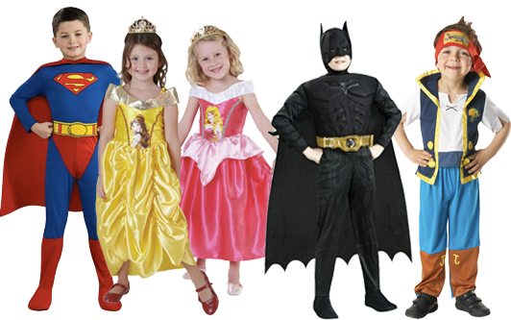
A) End-of-Term Party C) Birthday Party
B) Sleepover D) Fancy Dress Party

